**DAILY ONLINE ACTIVITIES SUMMARY**

|  |  |  |  |  |  |  |  |  |
| --- | --- | --- | --- | --- | --- | --- | --- | --- |
| **Date:** | 14/07/2020 | | | | | **Name:** | CHANDANA S | |
| **Sem & Sec** | 4th SEM ‘A’ SEC | | | | | **USN:** | 4AL18CS016 | |
| **Online Test Summary** | | | | | | | | |
| **Subject** | | N/A | | | | | | |
| **Max. Marks** | | N/A | | **Score** | | | N/A | |
| **Certification Course Summary** | | | | | | | | |
| **Course** | Data Science with Python | | | | | | | |
| **Certificate Provider** | | | Great Learning | | **Duration** | | | 3 Hours |
| **Coding Challenges** | | | | | | | | |
| **Problem Statement:** 1. Write a java program to check for balanced parenthesis. | | | | | | | | |
| **Status:** Completed | | | | | | | | |
| **Uploaded the report in Github** | | | | | YES | | | |
| **If yes Repository name** | | | | | https://github.com/chandushivalingareddy/lockdown-coding | | | |
| **Uploaded the report in slack** | | | | | YES | | | |

**Online Test Details:** N/A

**Certification Course Details:**

**Name of the course**: Data Science with Python

**Certificate Provider**: Great Learning

Today I had learned about measures of dispersion.

**Snapshot:**

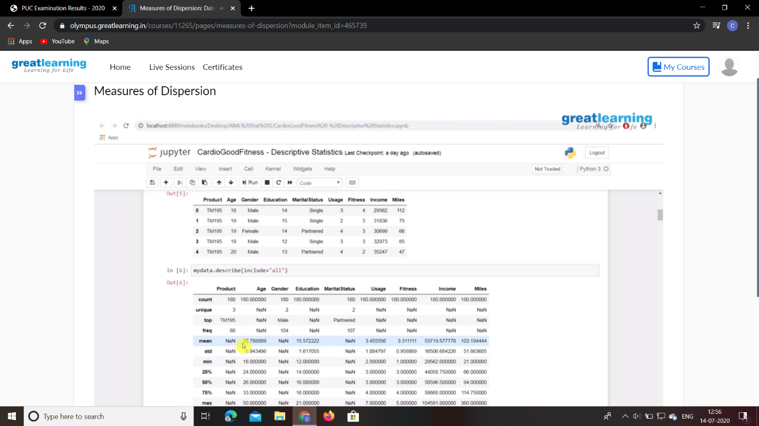

**Online Coding Details:**

Problem 1: Write a java program to check for balanced parenthesis.

**Snapshot:**

